FLOW-1: Dashboard or Menu Flow
1.1 Prescription Dashboard
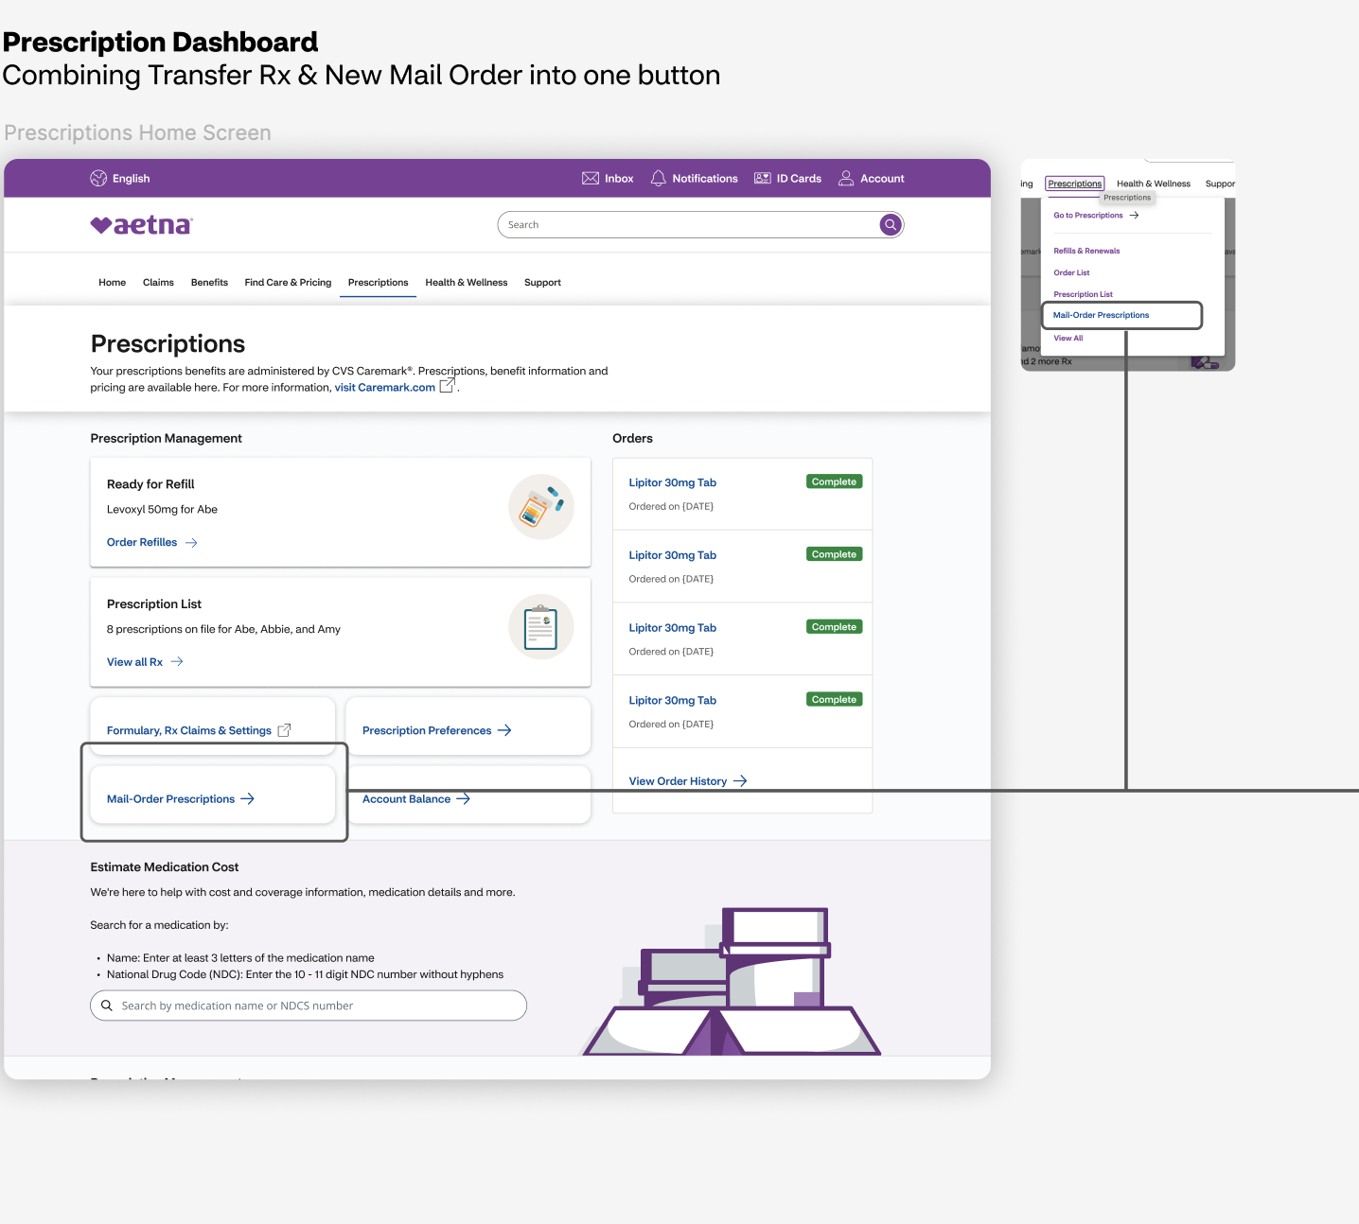
1.2. Mail Order Prescription Selection accessed from “Prescriptions” top level menu
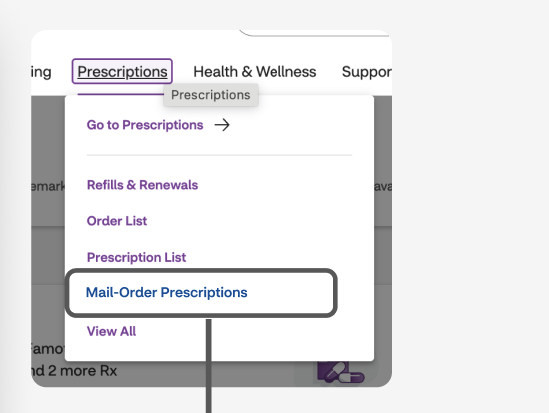

FLOW-2: Select or Request New Prescription Flow
2. New Mail Order Selection Page (whether accessed through 1.0 button or 1.a menu item)
2.a. New Mail Order Selection Page – Prescriptions ready to transfer but nothing selected yet
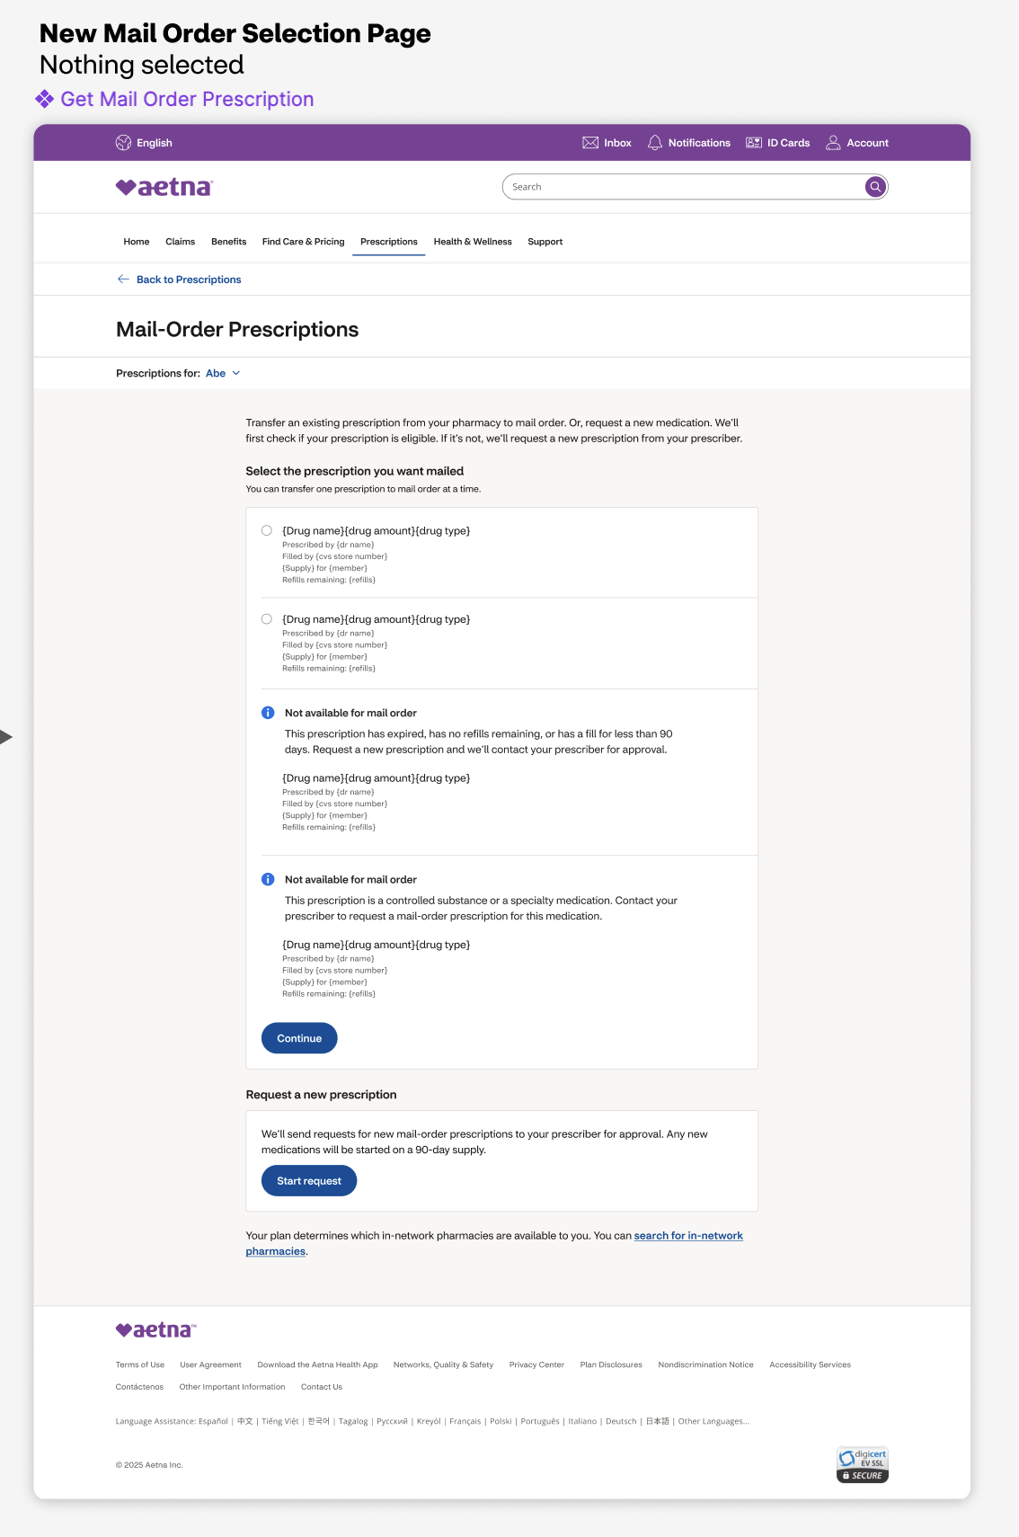
2.1.1. Connector: Select Existing Prescription. New Mail Order Selection Page. Existing prescription selected
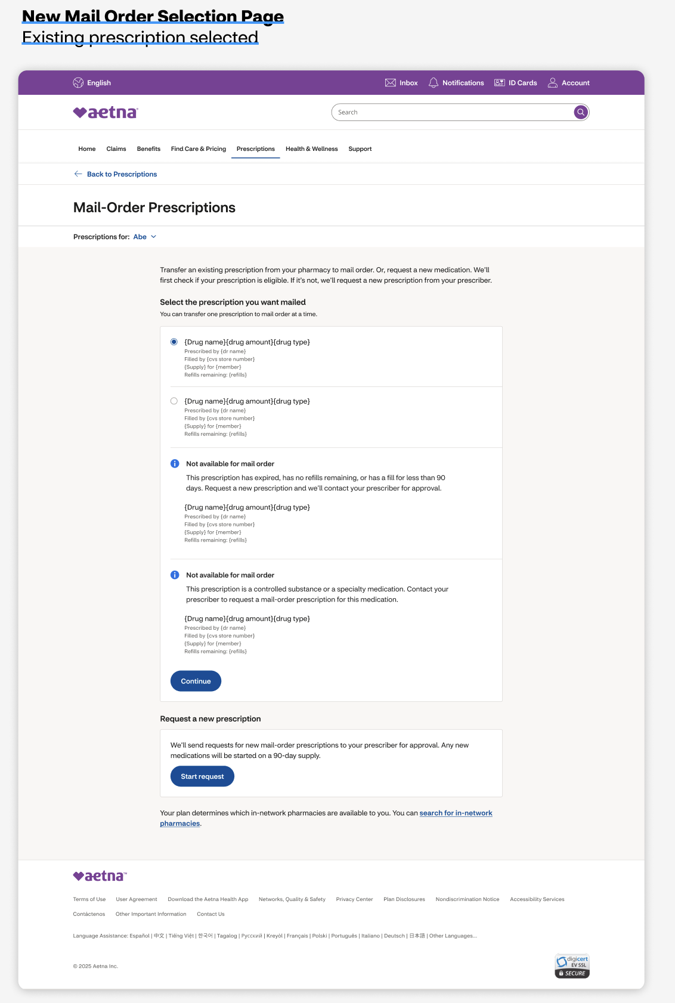

2.2. [Connector: none] New Mail Order Selection Page. No existing prescriptions. (gives option to add a medication)
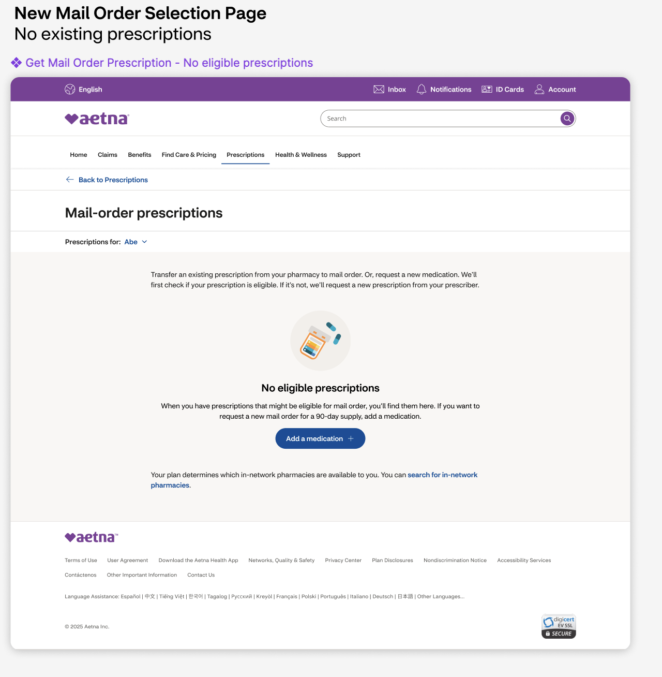
FLOW-3: Add New Prescription Flow (either from select existing or no existing pages)
3. [Connector: none] Add New Prescription Flow (new functionality alert & link if member requests medication they already have)
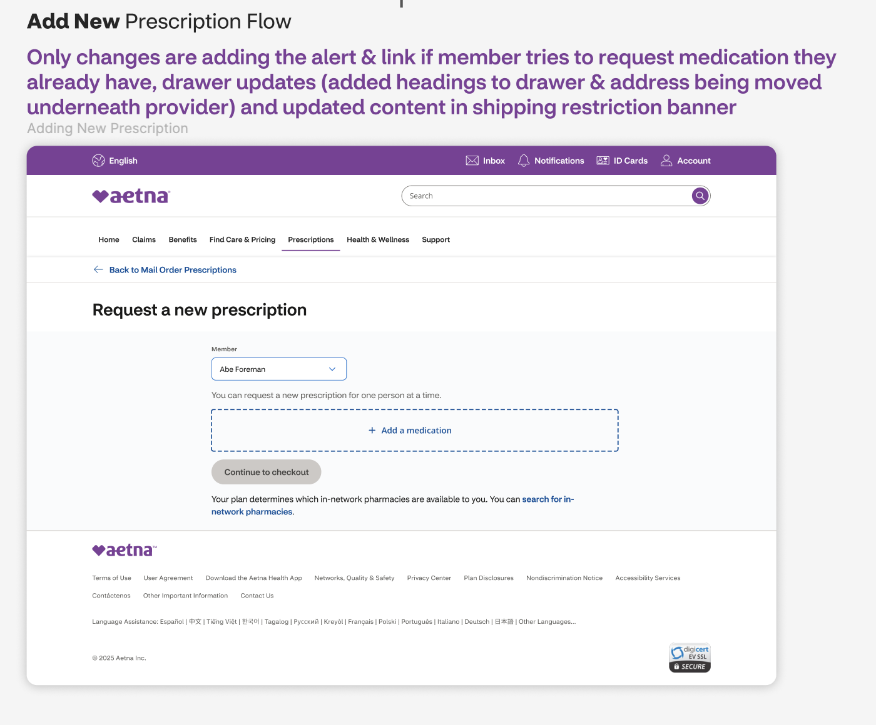
3.1. [Connector: none] Member tries to request medication they already have
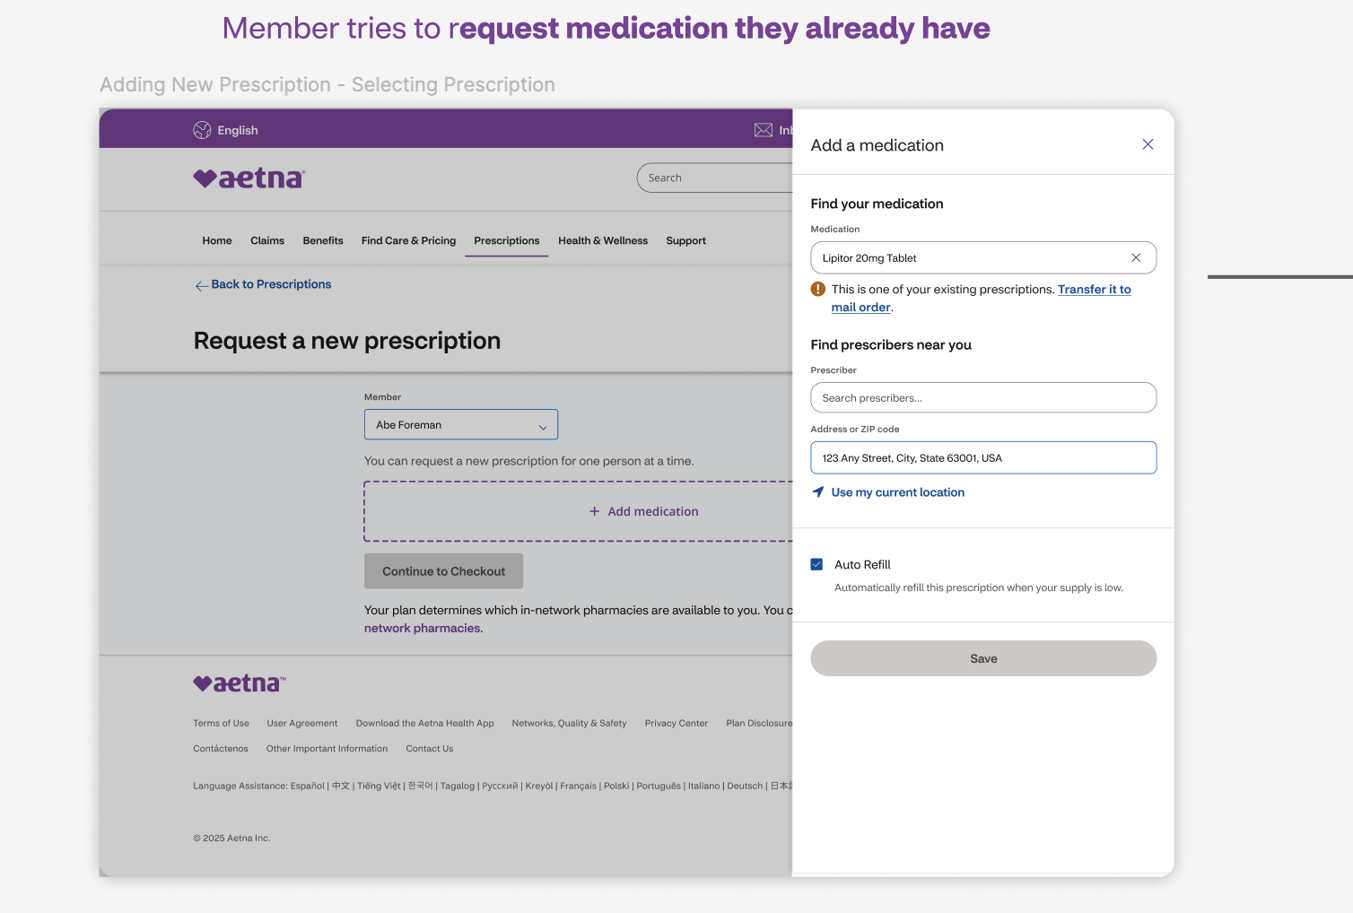
3.2. Adding New Prescription – Selecting Prescription
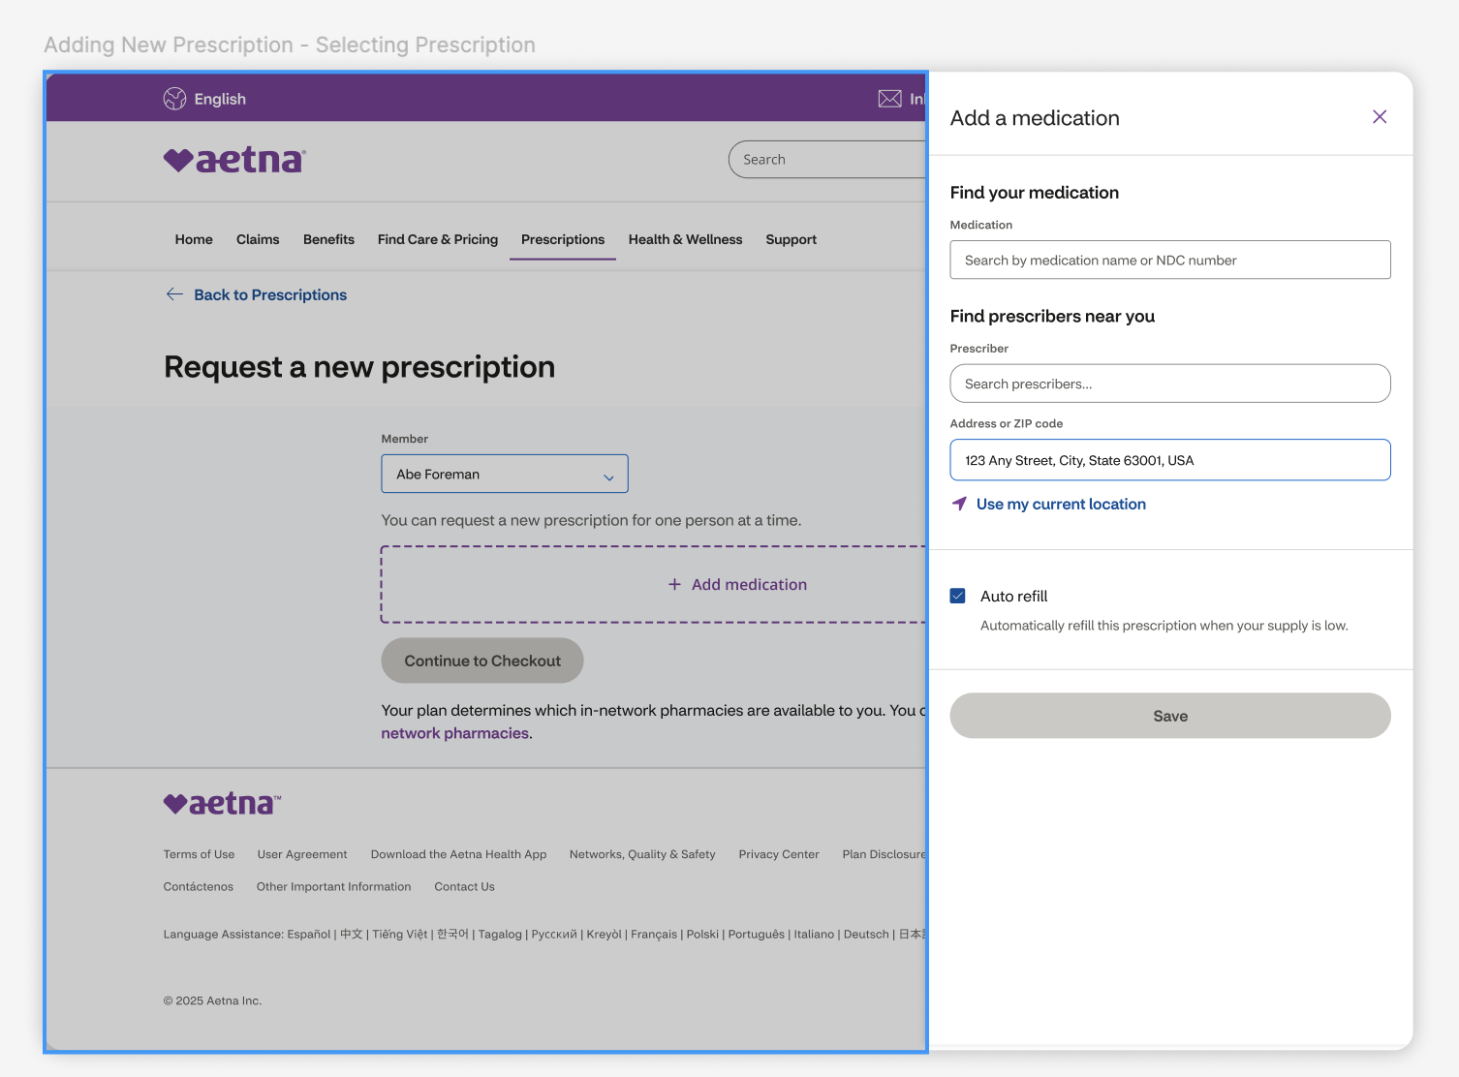
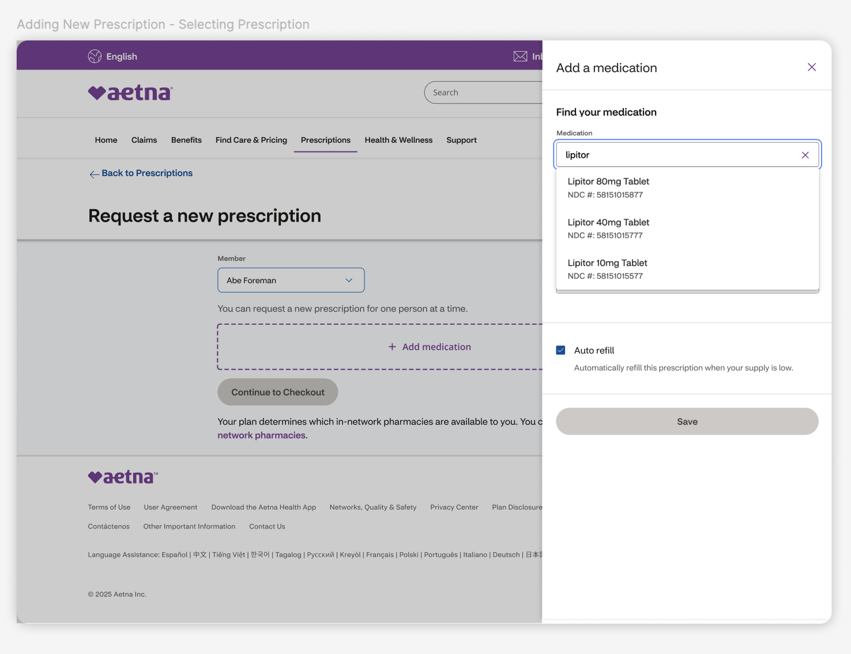
3.2. Adding New Prescription – Selecting Provider
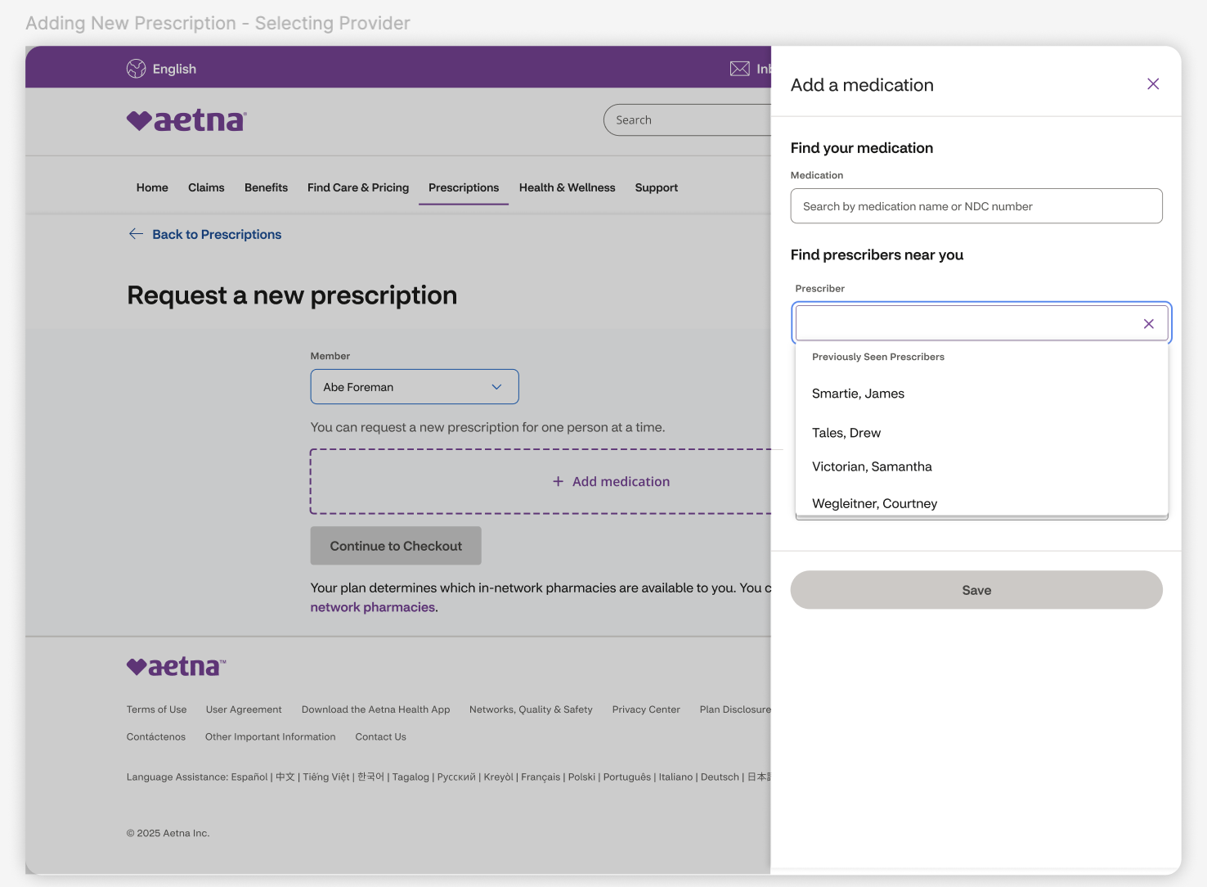
3.3. Adding New Prescription - Save
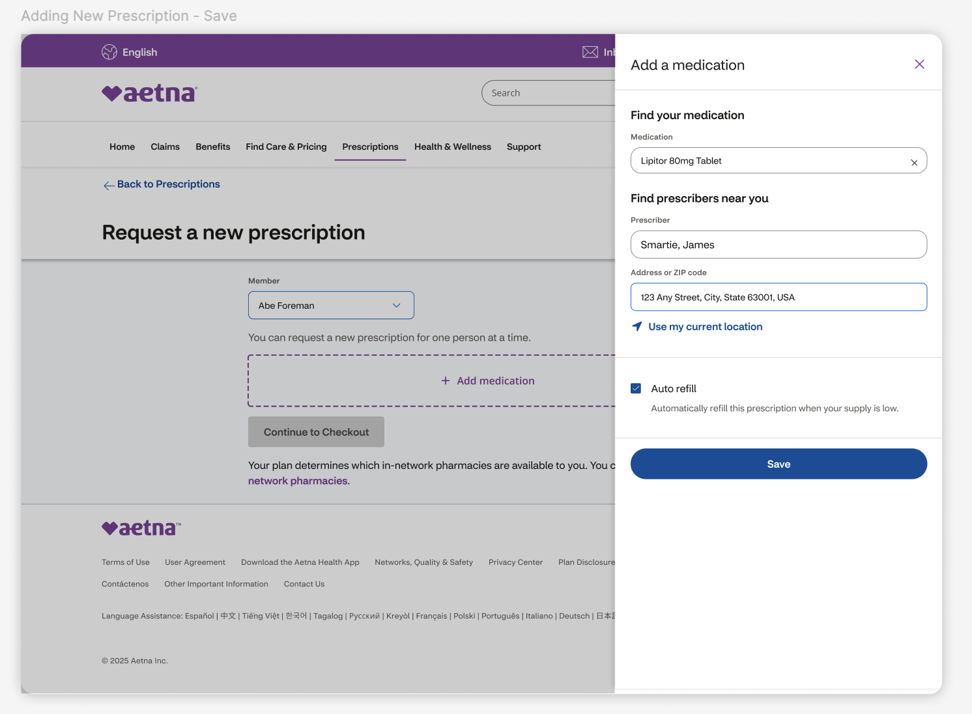
3.4. Adding New Prescription - Continue
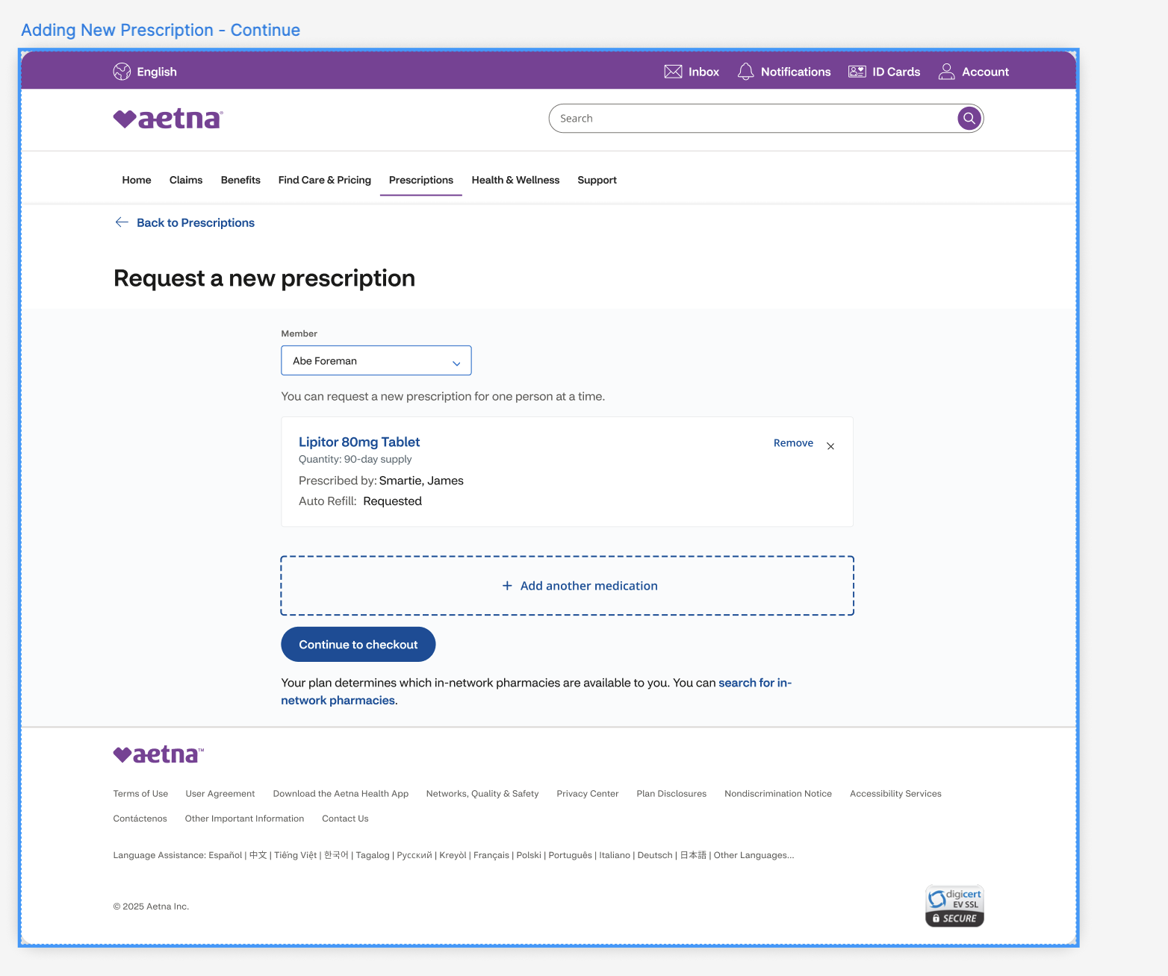
3.5. Jump to Flow-4 Transfer Eligibility Flow

FLOW-4: Transfer Eligibility Flow
4. Connector: API check happens here
4.1. [Connector: Transfer Eligible] Eligible Mail Order – Checkout
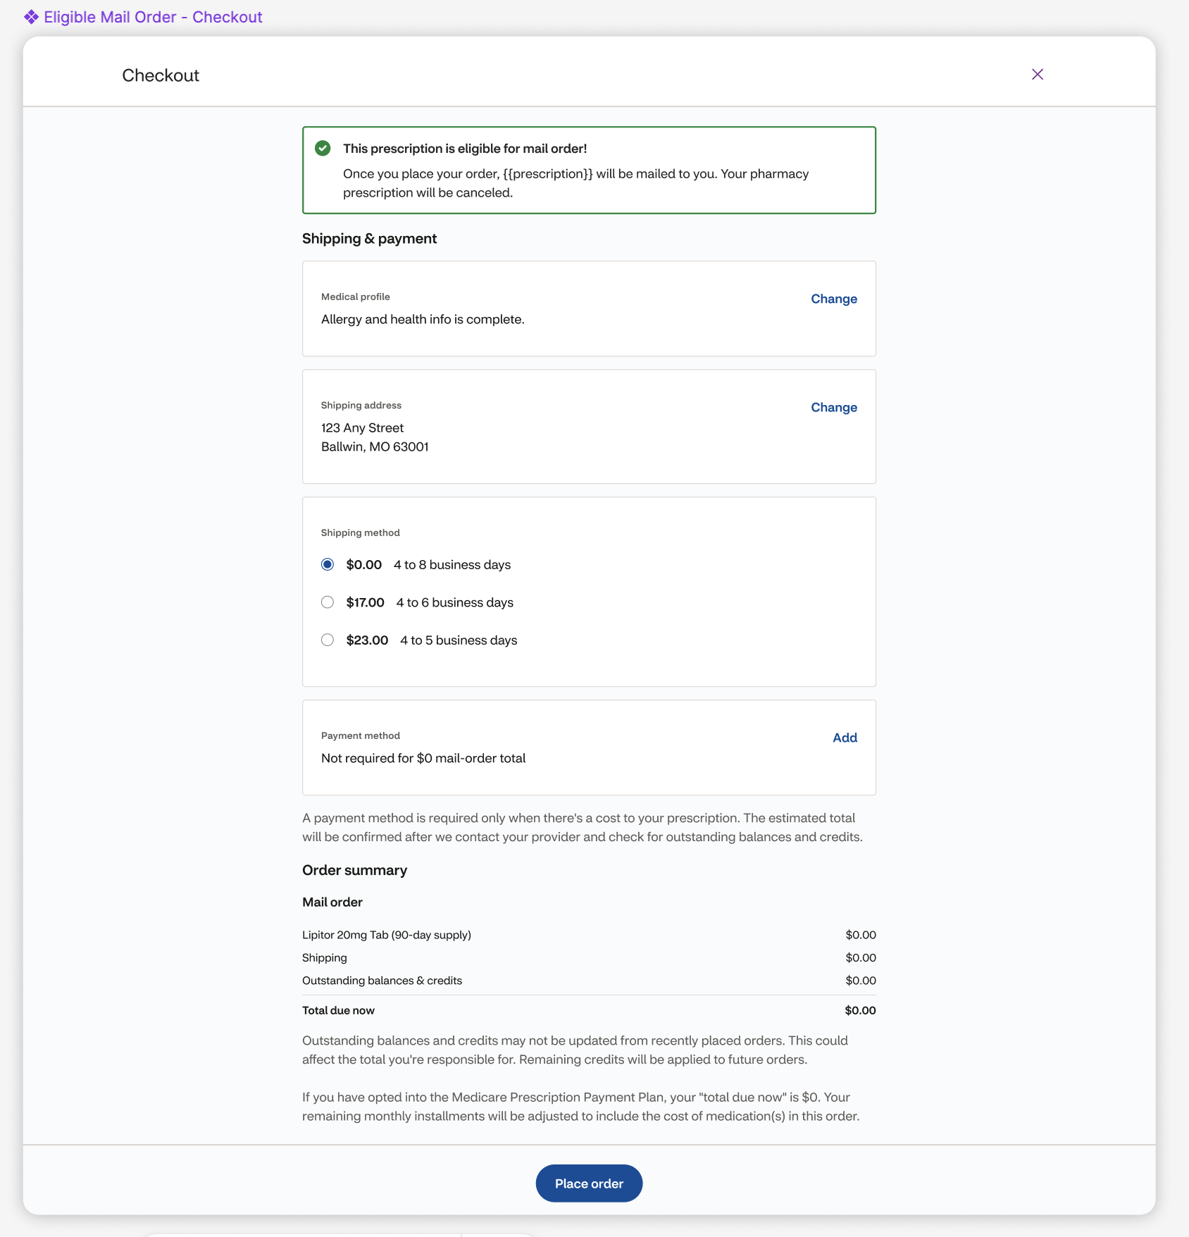
4.1.1. [Connector: no text] Eligible Mail Order – Confirmation
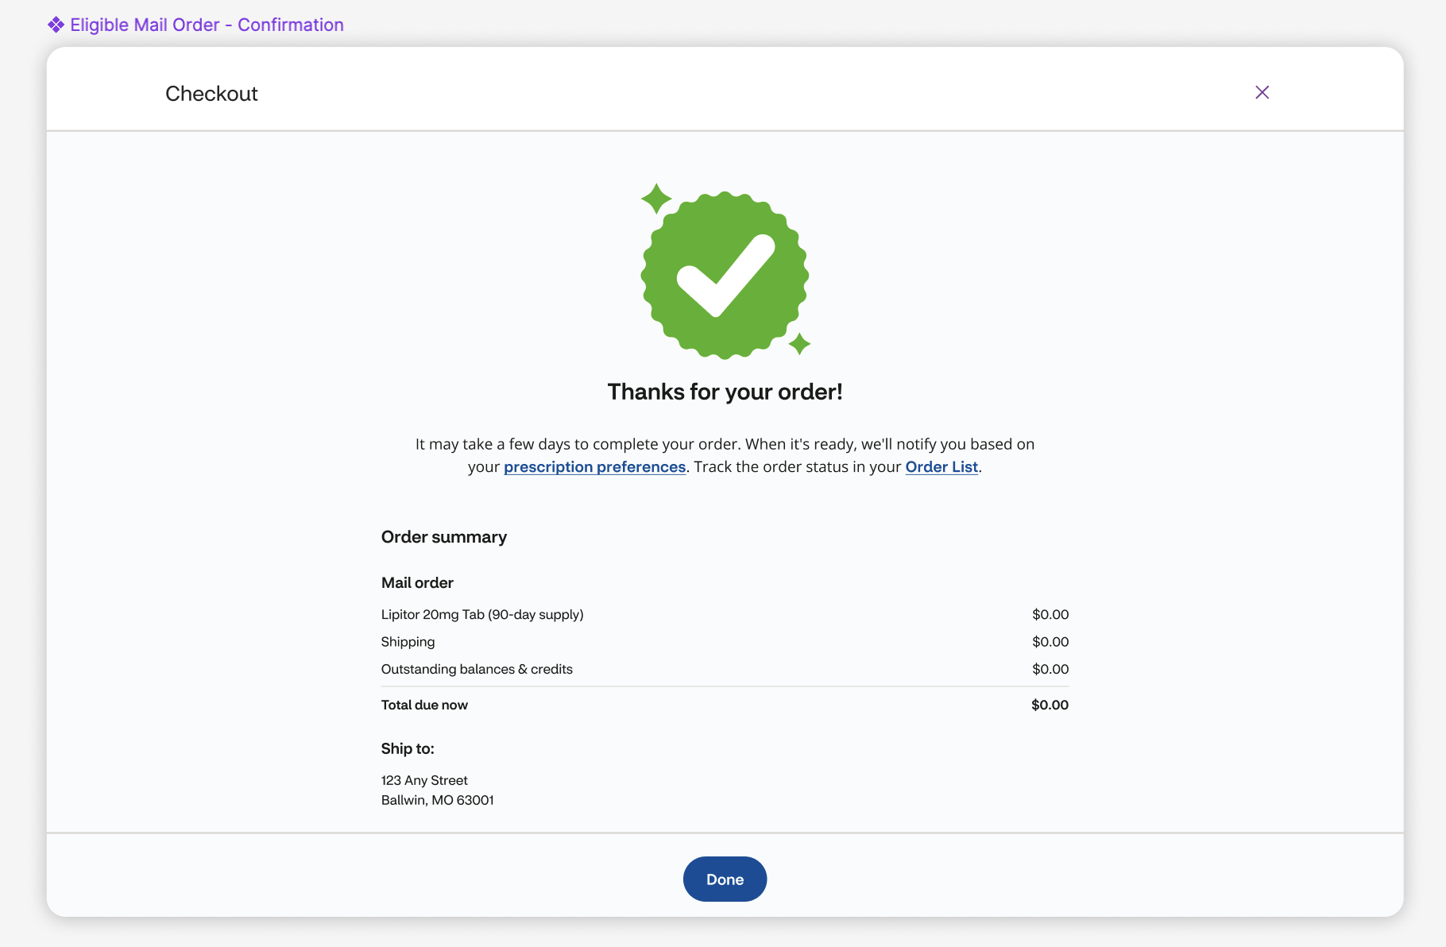
4.2. [Connector: Transfer Not Eligible (Provider Request Needed – FastStart)] Provider Approval Needed - Checkout
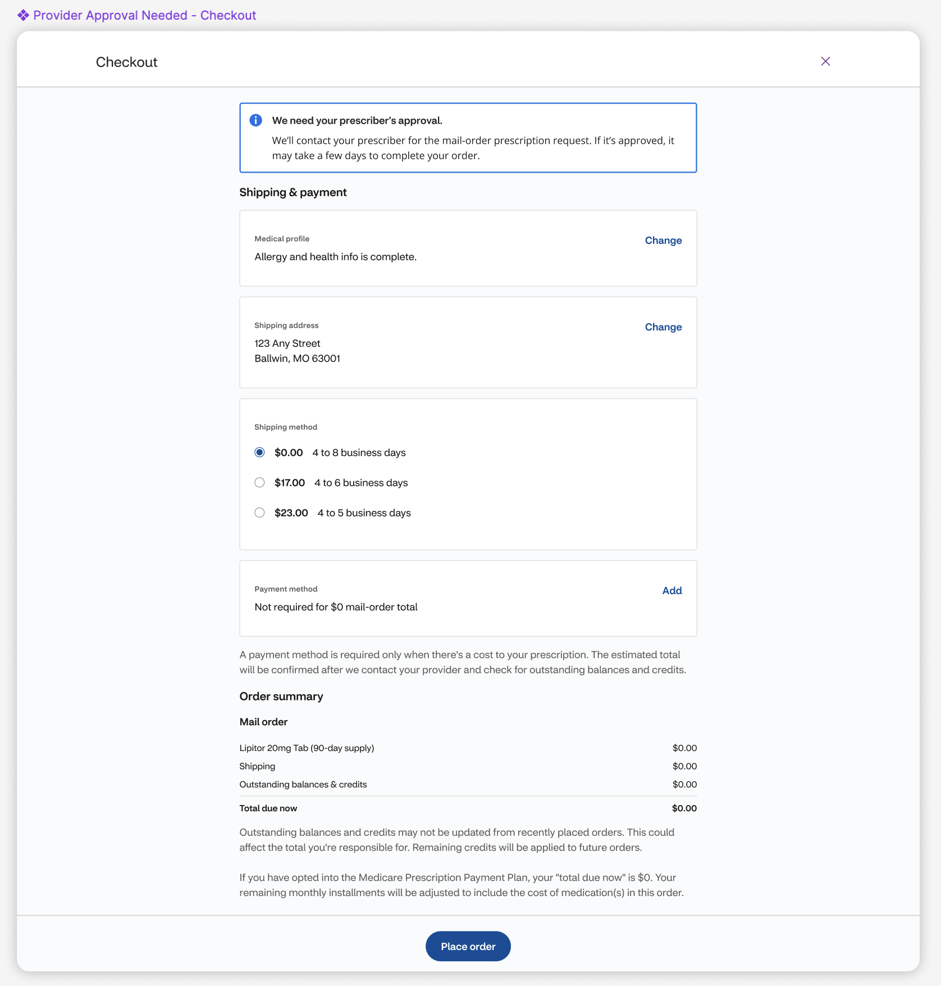
4.2.1 [Connector: none] Provider Approval Needed – Confirmation
